**MODULE: 2 (HTML)**

**• Define the terms: Website, Webpage, Web browser, Web server, HTML, CSS**

A set of interconnected webpages, usually including a homepage, generally located on the same server, and prepared and maintained as a collection of information by a person, group, or organization….

A location on the World Wide Web, consisting of one or more Web pages accessible at a single address….

**• Create a webpage to show “This is my first HTML page”**

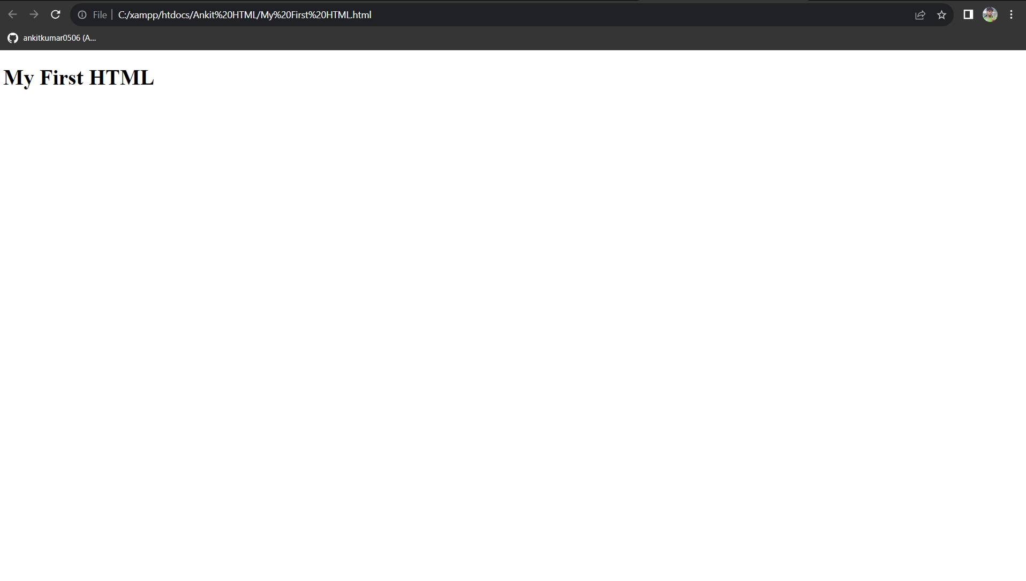

**• Display top 10 IT companies list in html webpage**

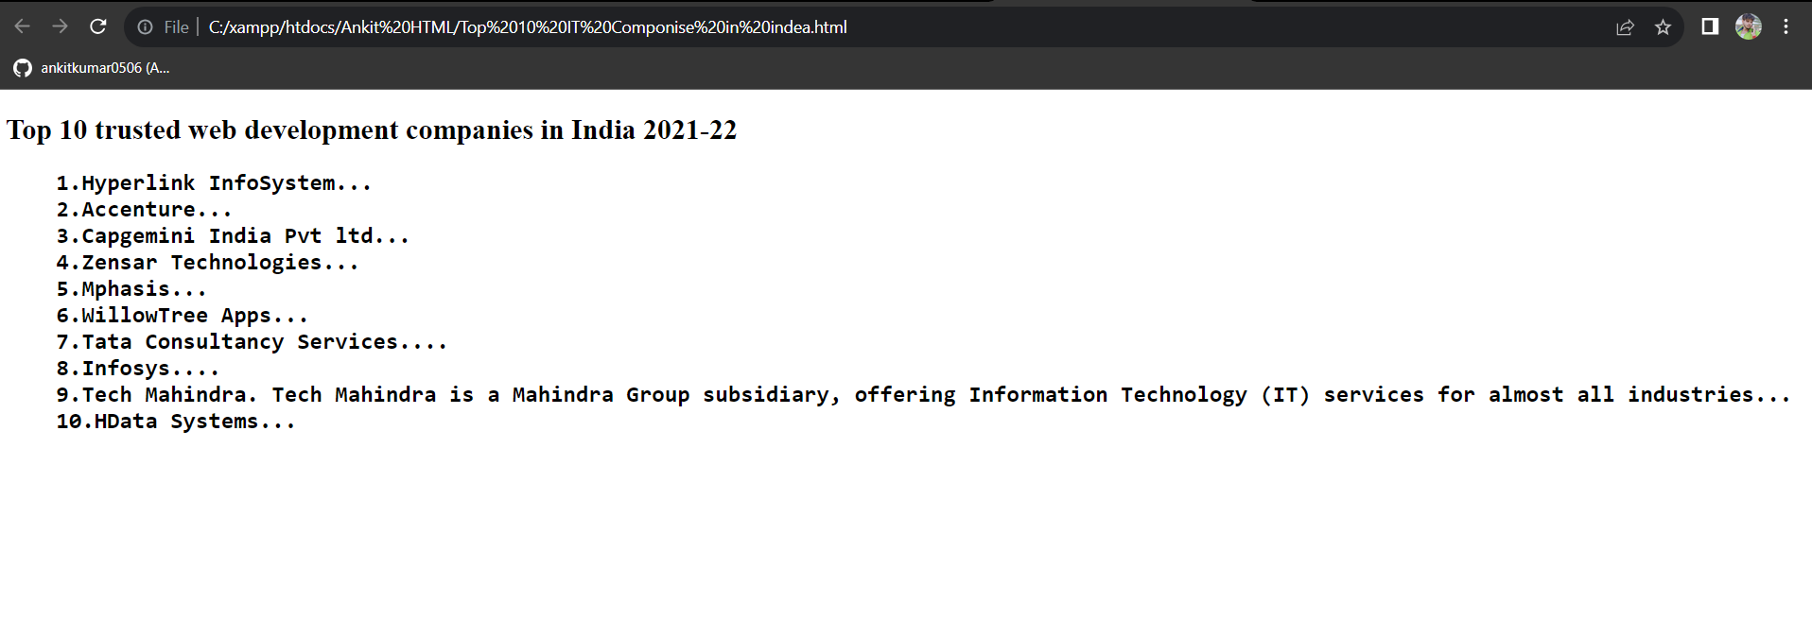

**• In how many ways can a CSS be integrated as a web page?**

CSS can be added to HTML documents in 3 ways:

**Inline** - by using the style attribute inside HTML element

**Internal** - by using a <style> element in the <head> section

**External** - by using a <link> element to link to an external CSS file